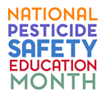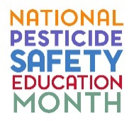

Sponsor Commitment Form
For Government Agencies

____The agency below commits to being an official sponsor of National Pesticide Safety Education Month. I understand that sponsorship by a government agency does not require a cash or non-cash contribution, but indicates that the agency recognizes the importance of public-sector education of pesticide users by land-grant university Pesticide Safety Education Programs (PSEP). I also understand that the agency’s logo or other identifier will be posted on the National Pesticide Safety Education Month homepage.

Government Agency Name: __________________________________________________________

Contact Name: _____________________________________________________________________

Contact Phone Number: ______________________________________________________________

Contact Email: _____________________________________________________________________

Thank you for sponsoring National Pesticide Safety Education Month, organized by the National Stakeholder Team for Pesticide Safety Education Program (PSEP) Funding.

Please submit this form by email to: wayne_buhler@ncsu.edu.

To cancel sponsorship at any time, simply re-submit this form with the following information included:

Cancellation Date: _________________________________________________________________

Contact Name: _____________________________________________________________________

Contact Phone Number: ______________________________________________________________

Contact Email: _____________________________________________________________________

